9th Grade Lesson 1: READ Strategy and GIST Statement

Opener: Vocabulary Word Map
Definition |  | Visual
Example 1 |  |  | Example 3
 | Example 2

During:

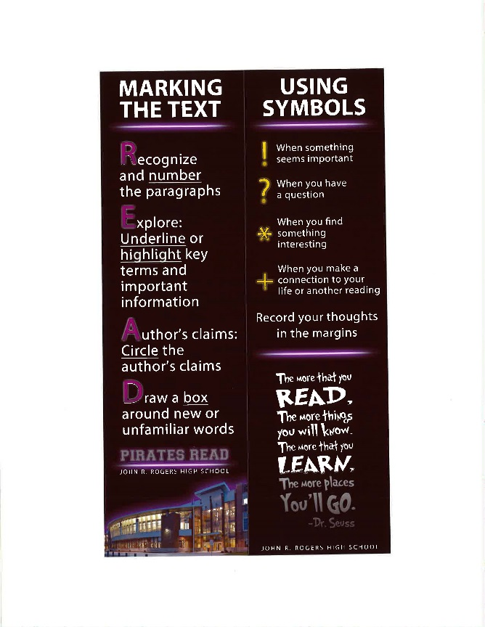

Focus

Student Discourse: Elevator Share
Once students have read and annotated, ask students to stand in their rows or at their tables. One at a time, students share an annotation, and then they sit once they have shared. Once everyone is seated, the class is ready to transition to the next activity.

The GIST Statement
By definition, the gist of a passage, conversation or other message is the essential message conveyed. Typically, that summary is limited to 20 words or fewer, which helps students eliminate extra details.
Closer: Student reflection on progress regarding learning targets.

